**Pandas Basics Assignments**

**(Data Scientist)**

**22nd Feb 2023**

**Q1. Create a Pandas Series that contains the following data: 4, 8, 15, 16, 23, and 42. Then, print the series.**

**Sol.**

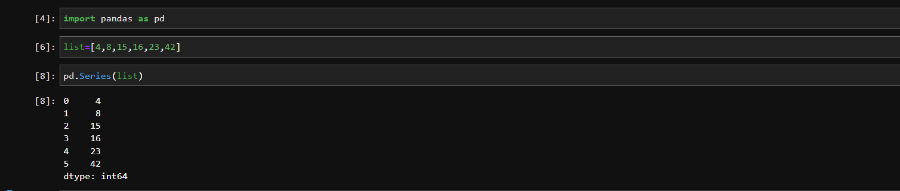

**Q2. Create a variable of list type containing 10 elements in it, and apply pandas.Series function on the variable print it.**

**Sol.**

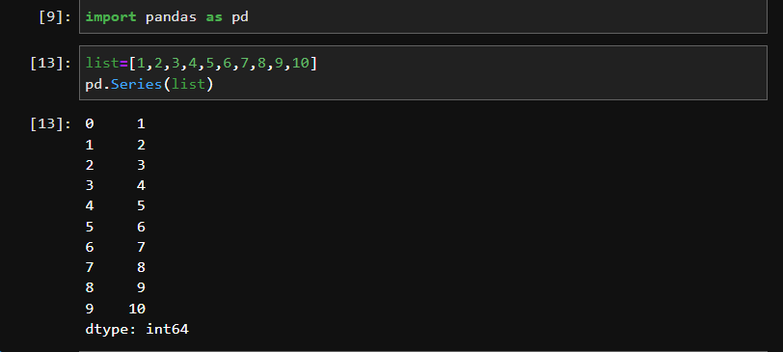

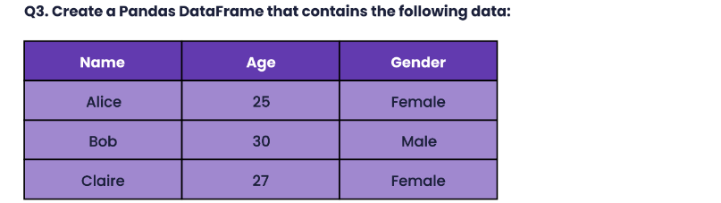

**Sol.**

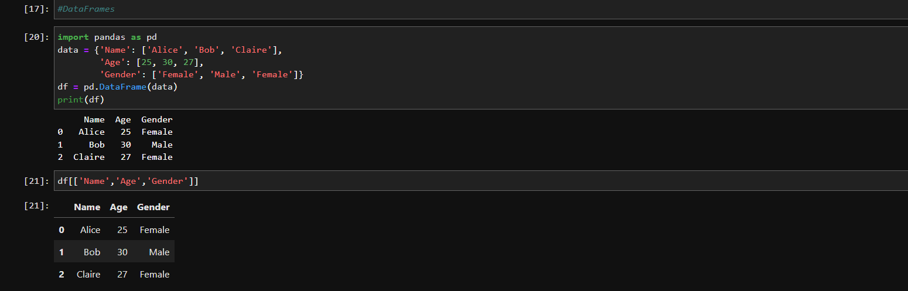

**Q4. What is ‘DataFrame’ in pandas and how is it different from pandas.series? Explain with an example.**

**Sol. *Pandas Series*** is a one-dimensional labeled array whose object size cannot be changed. You can also see it as the primary building block for a DataFrame, making up its rows and columns.

***Pandas DataFrame,*** is a two-dimensional structure with columns and rows whose size can be changed. You can also think of it as a dictionary of Series objects.

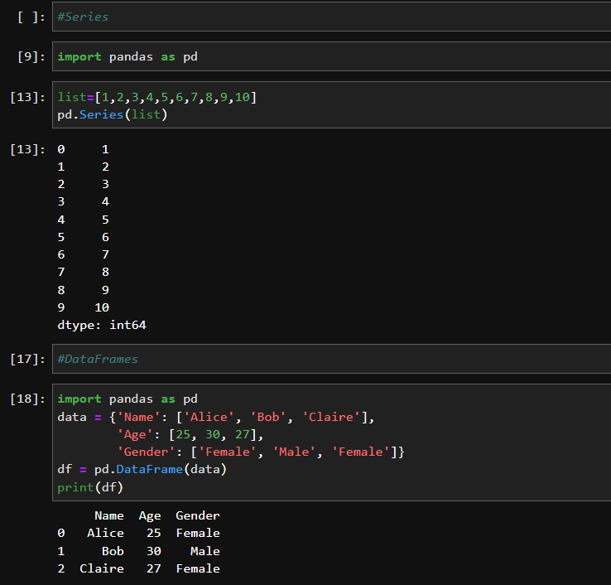

**Q5. What are some common functions you can use to manipulate data in a Pandas DataFrame? Can you give an example of when you might use one of these functions?**

**Sol.** Common Functions use to manipulate Data in a Pandas DataFrame is,

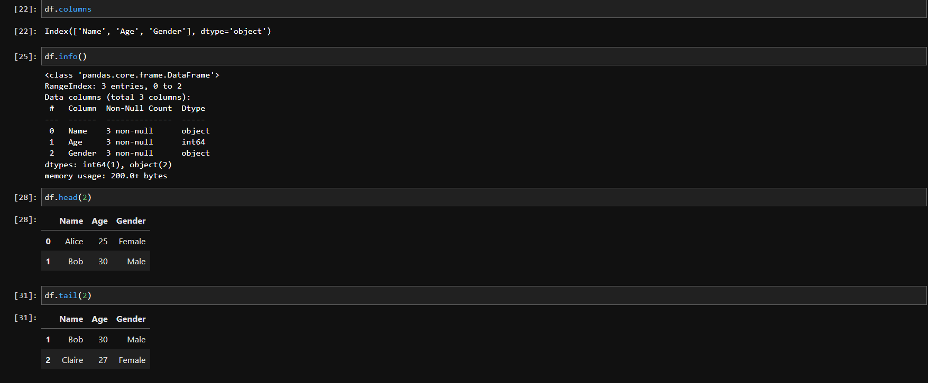

**Q6. Which of the following is mutable in nature Series, DataFrame, Panel?**

**Sol.**  **Series** is a 1-D size-*immutable array* like structure having homogeneous data.

**DataFrames** is a 2-D size-*mutable* tabular structure with heterogeneously typed columns.

**Panel** is a 3-D, size-*mutable* array.

**Q7. Create a DataFrame using multiple Series. Explain with an example.**

**Sol.**

